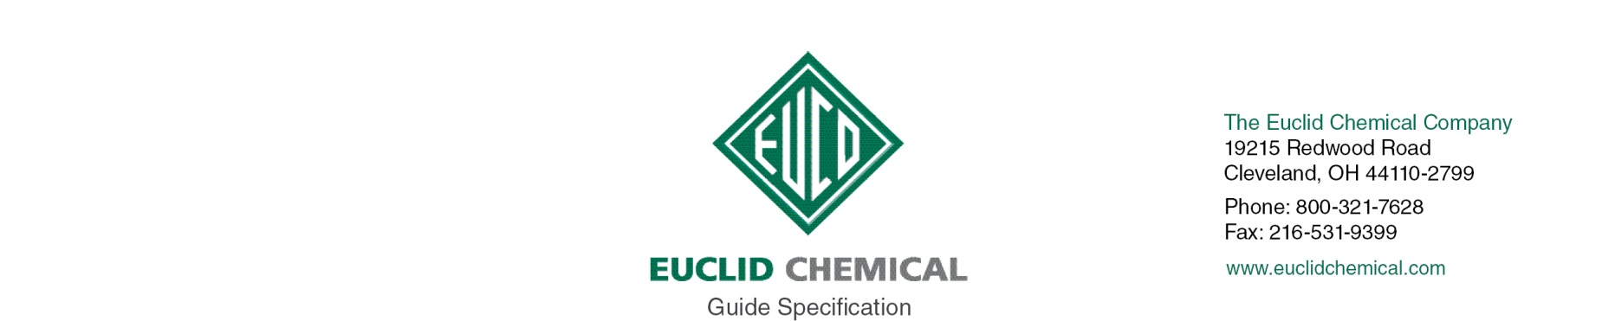
VANDEX UNI MORTAR 1 ZSR
NSF Approved Repair and Waterproofing Mortar

{Note to Specifier: The paragraphs below are meant to be incorporated into Parts 2 and 3 of a standard CSI 3 Part Format specification, project’s General Structural Notes or directly onto the plans. They must be carefully reviewed by a qualified design professional and edited to meet the particular requirements of the project at hand, assure compliance with any governing building codes, and coordinate with other specification sections and drawings.}

PART 2.0: PRODUCT

1.__ CEMENTITIOUS REPAIR AND WATERPROOFING MORTAR

{Note to Specifier: All of the material properties shown in the sub paragraphs below are not typically applicable on every project. They are listed here in order to allow the design professional to review and edit the information according to the particular project parameters for which the product will be used.}

A. Trowelable Horizontal, Vertical and Overhead Repair Mortar for Repairs up to1/2” per lift in depth. Fast setting, cement-based, one component repair and waterproofing mortar suitable for interior or exterior use. Material shall have the following properties:
1. Minimum 6,500 psi compressive strength at 28 days per ASTM C 109
2. Minimum 220 psi bond strength at 28 days per ASTM C321
3. Product:
a) Euclid Chemical Company (The), VANDEX UNI MORTAR 1 ZSR www.euclidchemical.com

B. Manufacturer shall have ISO 9001 Quality Certification. To ensure compatibility all associated products shall be from the same manufacturer.

C. To ensure compatibility, bonding agent and curing compound if used shall be from same manufacturer as repair mortar.

2.___ CURING

{Euclid Chemical recommends the following for maximum effectiveness}

A. It is essential that the material be wet cured for a minimum of 5 days. Once VANDEX UNI MORTAR 1 ZSR has hardened sufficiently, standard wet curing processes may be utilized. Wet or fog spray, or cover with polyethylene sheeting, wet burlap or burlene if a subsequent topical treatment is to be applied. If VANDEX UNI MORTAR 1ZSR is going to be the final finish, a water based curing compound may be applied. The mortar must be protected from rain during the first 24 hours and be protected from frost for at least 5 days. Use insulation blankets if necessary. Backfilling can occur 3 days after placement.

PART 3.0: EXECUTION

3.___ SURFACE PREPARATION

A. The surface should be structurally sound, clean and free of dirt, oil and other contaminants including curing compounds, form release agents, old coatings, paint and efflorescence. New concrete and masonry must be cured a minimum of 7 days. All concrete laitance must be removed. Mechanically prepare the concrete to a CSP 3-5 in accordance with ICRI Guideline 310.2. Concrete honeycombs, cavities, joints, cracks, voids, tie holes and other defects must be opened and routed to a ¾”depth or to sound material. No active water leaks should be present at the time of the application of VANDEX UNI MORTAR 1 ZSR. Use SPEED PLUG, VANDEX PLUG, or VANDEX SUPER mixed with VANDEX QUICKBINDER to stop all active leaks. Once prepared, the substrate needs to be soaked with water to a saturated, surface dry (SSD) condition just prior to the application of the material.

4.___ REPAIR MORTAR APPLICATION:

{TROWEL APPLIED APPLICATION}

A. After the substrate has been properly prepared and the surface is in SSD condition use a brush and apply a scrub coat of the mixed VANDEX UNI MORTAR 1 ZSR onto the substrate. Ensure that all cavities on the surface are filled. Don’t apply the scrub coat too far ahead of where the repair is being placed. The scrub coat must be covered by the initial lift before it dries out or it will become a bond breaker. Once the scrub coat has been applied, apply the first lift of mortar. The minimum thickness per lift is ¼”, while the maximum is ½”. If additional lifts are to be applied, wait approximately 2-4 hours for the last lift applied to tighten up. Using the side of a trowel or brush, score or texture the visible layer to give the additional layers a mechanical bond as well as a chemical bond. For small areas such as coves & fillets, VANDEX UNI MORTAR 1 ZSR may be applied up to 1-1/4” x 1-1/4” to create a smooth transition.

{SPRAY APPLIED APPLICATION}

A. VANDEX UNI MORTAR 1 ZSR may be applied using appropriate spray equipment, the recommended air pressure is approximately 73 psi with a delivery rate of 18 cu. ft. per minute using a 3/8” nozzle diameter. The first layer of VANDEX UNI MORTAR 1 ZSR is applied using a circular motion with the nozzle at a 90 degree angle to the substrate. Use a trowel or brush to texture the top lift if additional material will be applied. If needed spray apply additional lifts while the exposed layer is still “green” and can support the additional lift. Time between lifts is typically 2 to 4 hours depending on temperature and conditions.
1. *Application of topical treatments: Prior to the application of waterproofing or aesthetic coatings over the top of VANDEX UNI MORTAR 1 ZSR repairs, the material needs to be cured for 28 days.

2. *Filling of water retaining structures: Per standard water industry practices, filling VANDEX UNI MORTAR 1 ZSR repaired structures can occur once the material has had sufficient time to cure. This is usually after 14 days, but if the project is fast tracked and requires quicker filling, consideration may be given after 7days with an evaluation to determine if sufficient hardness has been obtained.

